SQL QUeries task

**Query 1:**

USE sql_store;

SELECT * FROM customers

WHERE customer_id=1

ORDER BY first_name;

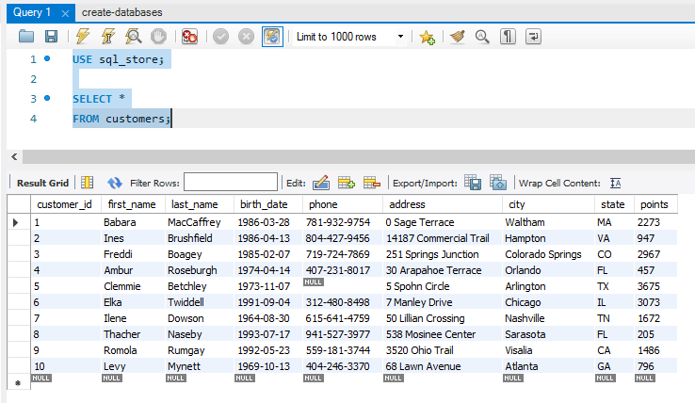

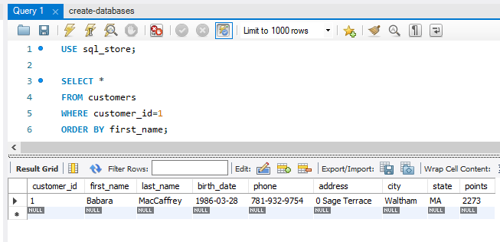

**Query 2:**

SELECT last_name, first_name, points, points + 10

FROM customers;

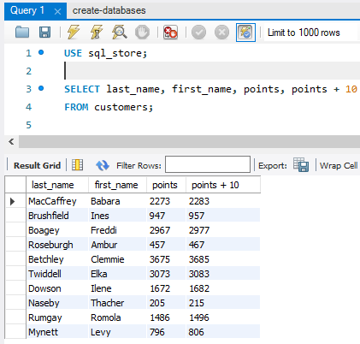

**Task 1.1: Change the points to read Times by 10 and Plus 100.**

SELECT last_name, first_name, points, points * 10 + 100

FROM customers;

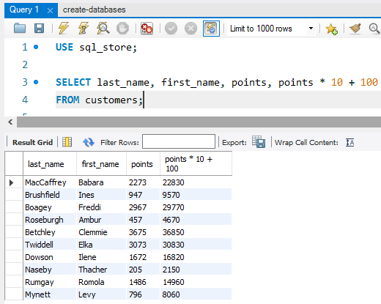

**Task 1.2: Create a discount factor so the table now shows a discount header and change the point to Plus 10 Times 100.**

SELECT last_name, first_name, points, (points + 10) * 100  
AS discount_factor  
FROM customers;

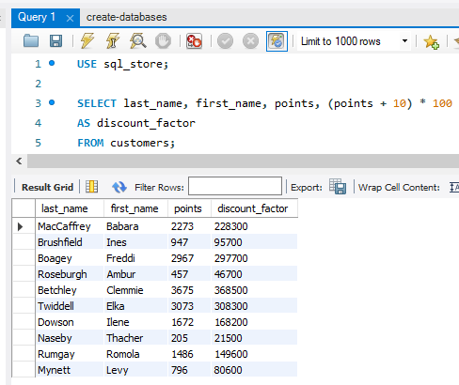

**Task 2: Write a SQL query to return all products in our database in the result set. Show columns; name, unit price and a new column called new price based on (unit price * 1.1).**

SELECT name, unit_price, (unit_price*1.1)

AS new_price

FROM products;

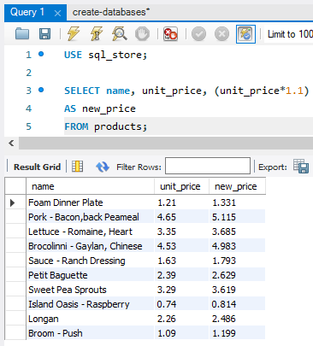

**Task 3: Create a query to find all customers with a birth date of > ‘1990-01-01’**

SELECT *

FROM customers

WHERE birth_date > ‘1990-01-01’;

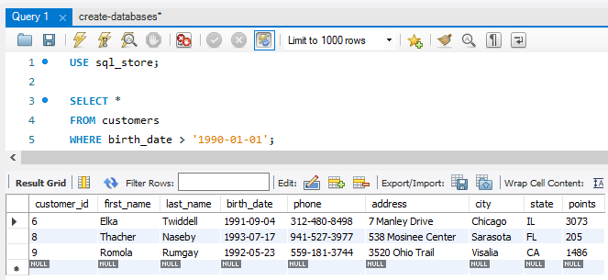

**Task 4: Write a query to find out the name of the product with most amount in stock.**

SELECT name, quantity_in_stock

FROM products

ORDER BY quantity_in_stock DESC

LIMIT 1;

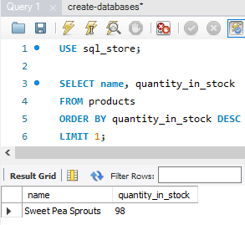

**Task 5: Write a query to find out the name of the most expensive product.**

SELECT name, unit_price

FROM products

ORDER BY unit_price DESC

LIMIT 1;

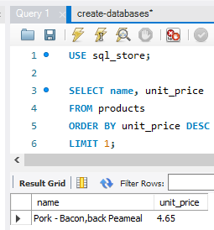

**Task 6: Write a query to find out the first name, last name, address and the birth date of the oldest customer.**

SELECT first_name, last_name, address, birth_date

FROM customers

ORDER BY birth_date ASC

LIMIT 1;

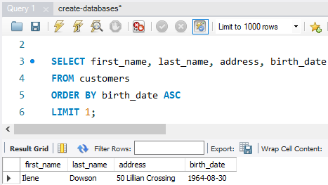

Creating an eer diagram

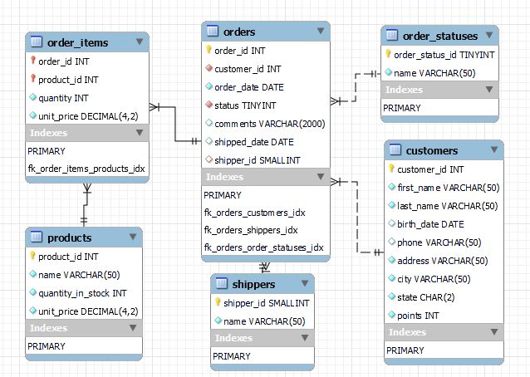

On our EER diagram we can see how the tables are related to each other as each table has its own Primary Key, such as order_id, product_id, shipper_id etc. Tables such as ‘order_items’ and ‘orders’ also contain Foreign Keys which relate them to a Primary Key of another table.